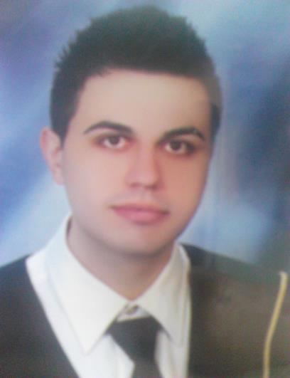

Filip Nikolovski

Skopje filip.nikolovski.peh@gmail.com

+389 78 749 731

I would join your team with pleasure, to accomplish our goals, in order to progress and gain new knowledge and friendships.

About me

Dedicated to work responsibilities, willing to learn and make progress, optimistic with team spirit, hard working and concentrate to work assignments, communicative, organized, agile, tolerant and loyal.

________________________________________________________
Skills

- Creativity

- Self trust

- Adjustable

- Persistence

- Team and individual work

- Ambitious

- Decisiveness

- Communicative
Languages

Macedonian – native

English – excellent

Serbian – good

Bulgarian – good

Education

BS formal education degree from

University of “St. Kiril and Metodij”

Faculty of Computer Science and Engineering (FINKI) Study program: Information technologies Direction: Internet and mobile technologies

________________________________________________________

Courses

CCNA Exploration: CCNA1, CCNA2 - Cisco Network Academy

________________________________________________________
Knowledge

Program languages: C++, C#, Java, HTML5, CSS, SQL, XML, asp.NET, MySql.

Basic knowledge of: JavaScript, PHP, Ajax, jQuery.

Software: Microsoft Office, Microsoft Visual Studio, Eclipse, NetBeans, Oracle Database Express Edition, Packet Tracer, Dreamweaver, Flash, Dia, Google Sketchup, Adobe Premiere

Projects

Preparation and participation in projects for the needs of the faculty: Android applications, web pages, web applications, databases, Java applications, animated videos, making programs for management and organization according to the e-business models etc.

Projects References

Diploma project:
http://managescienceworks.apphb.com/Index.aspx
https://github.com/filip-nikolovski/Manage-Science-Works (github)

HTML5 and CSS project:
http://angkorwat.apphb.com/wdproect.html
https://github.com/filip-nikolovski/Angkor-Wat (github)

Android project:
https://github.com/filip-nikolovski/QR-code-scan (github)
https://github.com/filip-nikolovski/QR-code-generate (github)

Experience

Two mounts as an intern responsible for promoting, maintaining and managing technical issues on www.elancer.mk website platform.

One month internship in National Examinations Centre, responsible for performing administrative and technical tasks in web application for external testing for high school students.
Hobby

Reading, listening to music, playing basketball, web surfing, walking, mountain climbing, social games.

